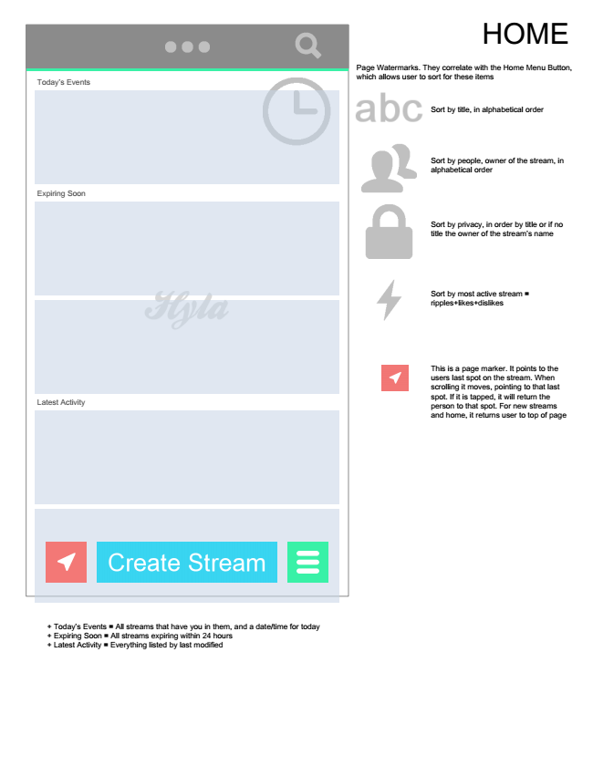

Today’s Events

Expiring Soon

Latest Activity

+ Today’s Events = All streams that have you in them, and a date/time for today + Expiring Soon = All streams expiring within 24 hours + Latest Activity = Everything listed by last modified

Page Watermarks. They correlate with the Home Menu Button, which allows user to sort for these items

Sort by title, in alphabetical order

Sort by people, owner of the stream, in alphabetical order

Sort by privacy, in order by title or if no title the owner of the stream’s name

Sort by most active stream = ripples+likes+dislikes

This is a page marker. It points to the users last spot on the stream. When scrolling it moves, pointing to that last spot. If it is tapped, it will return the person to that spot. For new streams and home, it returns user to top of page

HOME

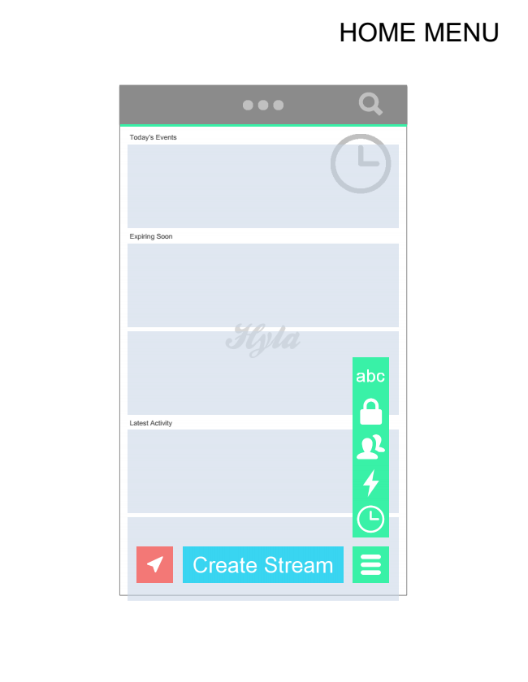

Today’s Events

Expiring Soon

Latest Activity

HOME MENU

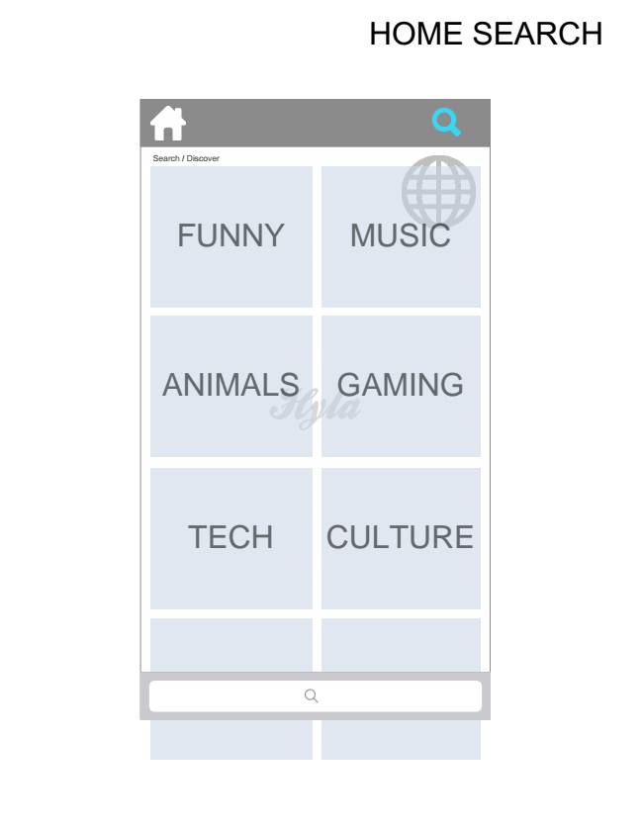

Search / Discover

FUNNY

MUSIC

ANIMALS GAMING

TECH CULTURE

HOME SEARCH

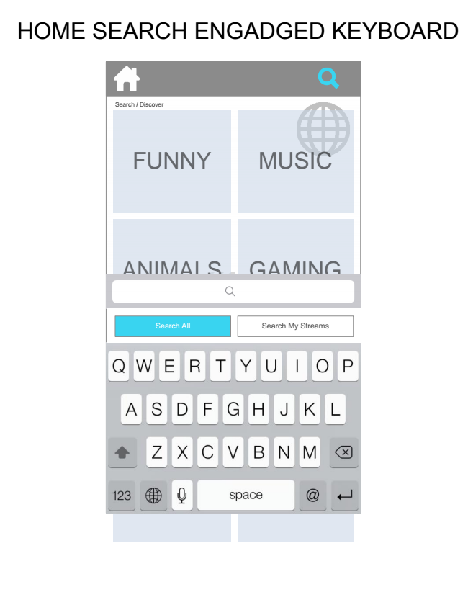

HOME SEARCH ENGADGED KEYBOARD

Search / Discover

FUNNY

MUSIC

ANIMALS GAMING

Search All Search My Streams

TECH CULTURE

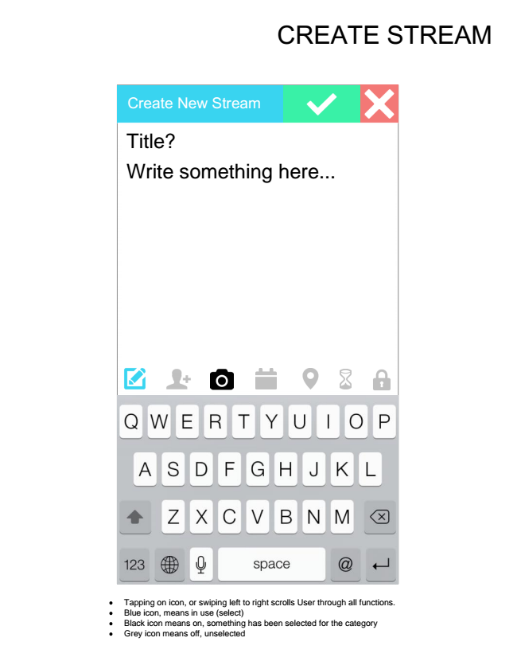

Tapping on icon, or swiping left to right scrolls User through all functions.

Blue icon, means in use (select)

Black icon means on, something has been selected for the category

Grey icon means off, unselected

Title? Write something here...

Create New Stream

CREATE STREAM

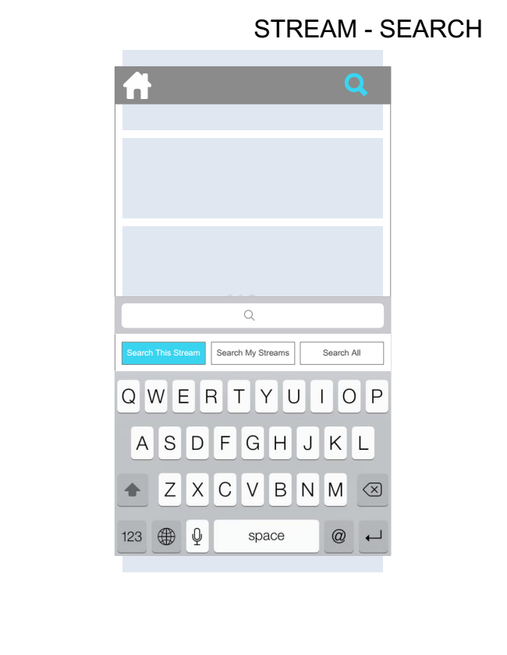

STREAM - SEARCH

Search This Stream Search My Streams Search All

TECH CULTURE

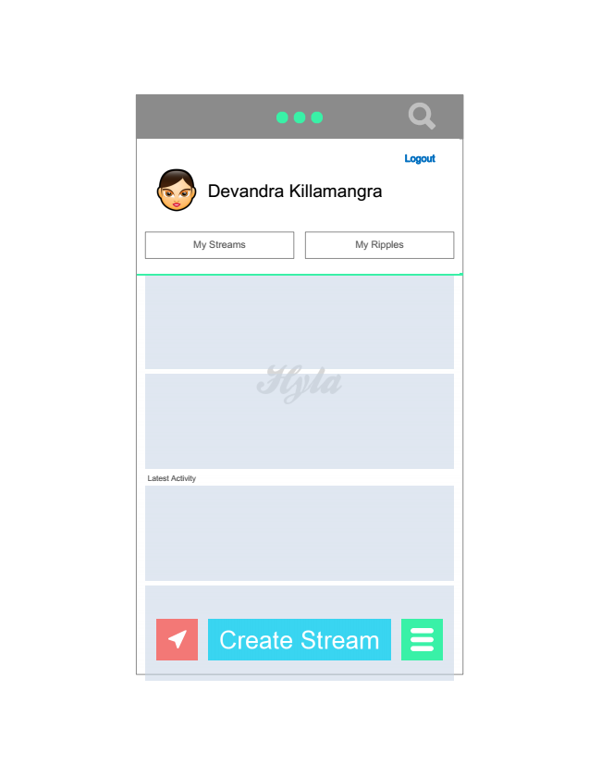

Today’s Events

Expiring Soon

Latest Activity

Devandra Killamangra

My Streams My Ripples

Logout